**SMC Climate-Disturbance analysis update**

Nov 4, 2023

Clayton Lamb

**TL;DR**

Habitat productivity is increasing within SMC primarily due to disturbance. Climate change is altering weather patterns. Caribou have primarily declined in last 50 years due to disturbance not climate change or weather. Disturbance thresholds remain elusive due to lambda<1 but the greatest chance of self-sustaining occurs at low disturbance, well below the 35% threshold. A possible threshold around <25% of matrix disturbance and <5% high elevation is starting to emerge. Overall, due to mostly having data on declining populations there is a need to restore habitat and find out if self-sustaining is possible. The very expensive cousin of “fuck around and find out”.

**Longer Summary**

The goal of this work is to assess the degree to which climate change and disturbance have each contributed to the severe declines and extirpations of southern mountain caribou in the last half century (1970+). We are taking a mechanistic, hypothesis-driven approach to this question. The hypothesized paths through which disturbance or climate could impact southern mountain caribou demography are shown in Figure 1.

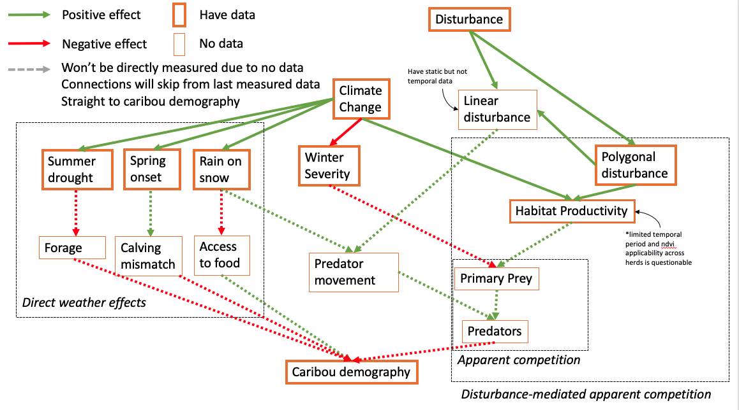

*Figure 1.*

Due to constraints in gathering a complete dataset that had fully populated covariate data across all years and all herds, we’ve broken the analysis into 3 components to assess distinct aspects of the mechanistic pathways while making efficient use of all data available (Figure 2). At a high level there are a few ecological pathways that disturbance and climate could affect caribou demography. 1) polygonal disturbance (clear cuts, well pads, etc) can increase early seral on the landscape and trigger the disturbance-mediated apparent competition cascade which is well described elsewhere (Holt 1977, Serrouya et al. 2021), or, 2) the apparent competition pathway could be triggered by climate change either through increases in habitat productivity due to longer growing seasons or through reduction in limiting winter conditions for white-tailed deer (Latham et al. 2011, Dawe and Boutin 2016, Laurent et al. 2021), or, 3) weather may be directly impacting caribou forage quality during hot summers, calf survival as spring mismatch occurs, access to food under crusted snow, and climate change may be changing the frequency of these weather events (Tyler 2010, Cook et al. 2021, Denryter et al. 2022). A fourth pathway may act through changing predator movement efficiency through either increases in crusted snow or linear features but empirical evidence suggests this mechanism is unlikely to explain major declines in caribou populations, but can be a component of the declines (Spangenberg et al. 2019, Serrouya et al. 2020).

Analytical Overview:

* Analysis A tests whether habitat productivity is changing through time—a key aspect of the apparent competitor hypothesis—and assesses whether this change through time is better explained by changes in climate or polygonal disturbance. Done by splitting out the disturbed vs undisturbed portions of each herd and compare changes in habitat productivity (indexed by NDVI or EVI) through time for each portion. Climate change should impact the undisturbed portion while disturbance and climate change impact the disturbed portion, allowing for an isolation of each effect (unless it’s strongly interactive).
* Analysis B tests whether the hypothesized weather variables are changing through time, indicative of climate change affecting these weather patterns. Done via simple mixed model to assess change through time.
* Analysis C tests whether changes in polygonal disturbance or weather better explain the observed changes in SMC demography (survival, recruitment, and population growth). This will be done via an IPM.

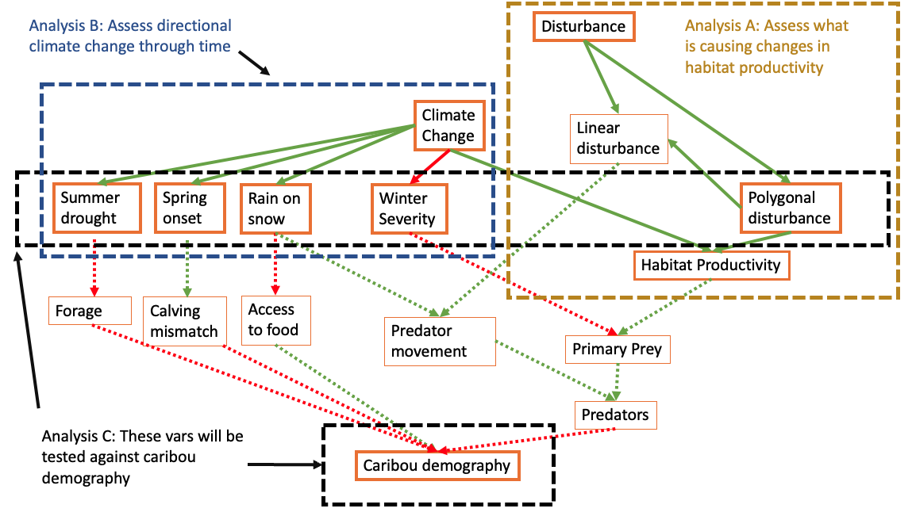

*Figure 2.*

**Results**

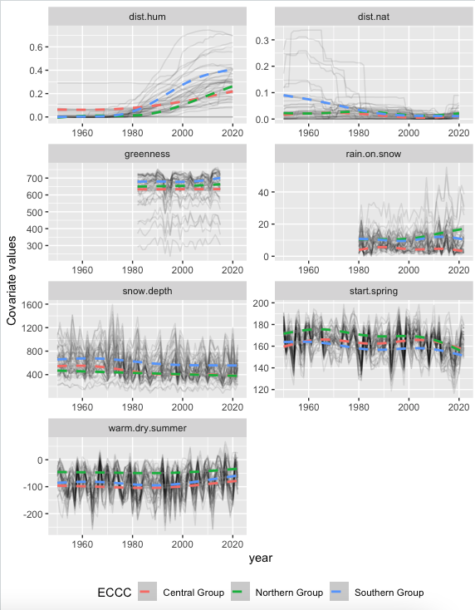

*Figure. Overview of covariates considered. Natural disturbance not considered in the following models due to fires covering a small area compared to human disturbance and the decline in fires observed through time being an unlikely driver of SMC declines.*

***Analysis A:*** An overall trend of increasing habitat productivity (NDVI/EVI) was detected and the rate of increase appeared to increase post 2000. Habitat productivity was consistently increasing much faster in disturbed areas than in undisturbed areas providing strong evidence for the disturbance-mediated portion of the apparent competition hypothesis and little evidence for climate as the dominant driver of changes in habitat productivity (Figure 3).

*Figure 3. Estimated change in EVI/yr by ecotype and disturbed (evi.dist) vs not disturbed area (evi.nodist ) and all areas (evi). This is a crude analysis and I can refine it if this stays in the paper. I used a conservative disturbance layer so there is likely some disturbance in the “no.dist” category and I suspect a more refined approach will further reduce any evidence for climate and increase strength of disturbance effect. Assessed via glmm with random slope and intercept for each herd.*

***Analysis B:***Weather was directionally changing through time and the effect was similar across

ecotypes except for rain on snow which was changing most in northern group. This is a simple analysis to establish whether these weather variables also represent some level of climate change and longer-term changes that could be driving observed caribou declines.

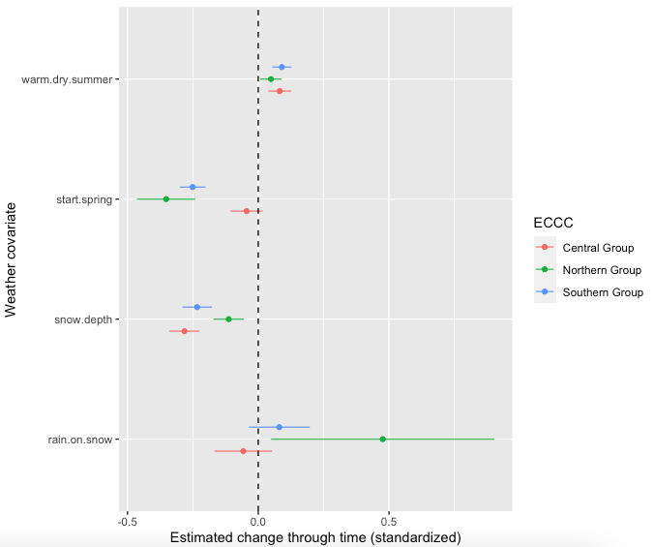

*Figure 4. results from glmm with random slope and intercept for each herd*

***Analysis C:*** The analyses above provide evidence above that polygonal disturbance, not climate, is the primary cause of the increases in habitat productivity observed within SMC (analysis A) and that weather patterns are changing within SMC (analysis B) which could be having direct effects on caribou.

I included the 5 covariates identified in Figure 2 and measures of caribou demography between 1974-2021 within an Integrated Population Model. Specifically, I considered 4 climate variables (hot summers, spring onset, snow depth, and rain on snow) and one disturbance variable (proportion of herd area with cut blocks that were 10-40 years old, and the proportion of area that was well pads—FYI this ends up about the same as just using cutblocks). These variables were included in the IPM through independent effects on survival and recruitment. I conducted a post-hoc analysis to assess how these variables influenced population growth to provide an overall effect at the population level.

This analysis provides compelling evidence that human disturbance has been the primary driver of declines in SMC. There are some vital rate-specific climate effects, such as the start of spring, but none that translated to changes in population growth due to opposing responses in other vital rates.

*Figure 5. results from IPM (lambda is post hoc glm for now but I will get into IPM soon).*

**Take home so far:** Climate change is altering weather patterns in SMC herds. Human disturbance is increasing habitat productivity which is known to increase apparent competition through a numeric response in predators and their primary prey. Changes in SMC abundance was best explained by the human disturbance footprint, which has substantially increased through time.

**Additional analyses looking for a disturbance threshold and assessing high vs low elevation disturbance**

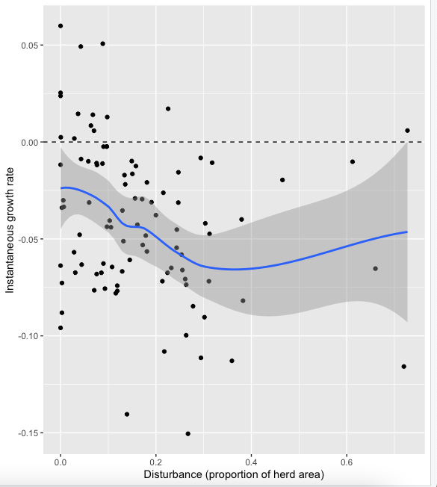

*Figure—decadal growth rate and mean proportion disturbed for SMC. The overall trend shows that declines are likely across all levels of disturbance, but increases and stability generally occur most often at low polygonal disturbance levels (<0.1, or <10% area with cutblocks and well pads [with 500m buffer])*

*Figure—Stable (lambda >=1) populations of at least 50 individuals compared to the proportion of area disturbed in high and low (matrix) elevation critical habitat. Possible “disturbance threshold area” shown in rectangle.*